HW 13-TK-Hillel-BA IT-ENG-Testing v 1.2

Создать документ в котором описать план подготовки и проведения А/В тестирования в котором предложить сравнить два варианта дизайна страницы/скрина Вашего продукта (дизайн создаем и вкладываем в документ).

**A/B Testing of RBA ROMA Visual Appearance**

In order to determine a better and more attractive appearance of the App, A/B Testing shall be conducted on evaluation of potential interface version One (aka “white”) versus potential interface version Two (aka “dark”). The activities are planned to be performed in the form of an electronic survey for the group of 500 to 1000 users: sent via the App and to user’s email or messenger channel (TBD), and via laboratory tests based on the paper-based versions of tests among the team within the Project.

**The Scope of Testing**

1. **Planning**
   1. Survey Composition
      1. general information blocks (3 to 5) as warm-up instructions and intro questions
      2. interface comparison
      3. proposals
      4. light feedback (quantifiable)
      5. ...
   2. Elaboration of criteria and metrics to be checked/examined
   3. Resource allocation and nomination
   4. Segmentation of users
      1. by age
      2. by intensity of use
      3. by random factor One (would you be so kind to spend some minutes answering a few questions...)
      4. by random factor Two (would you be so kind to spend some minutes answering a few questions...)
      5. ...
2. **Testing**
   1. **Email-sent surveys or sent by other channels surveys**
      1. [**Mobile Banking Testing Survey**](https://docs.google.com/forms/d/e/1FAIpQLSdwGU1TrAsVOZ4VlAJQ2CKOBDT1BkolGkXOQyI8Jsb9VBLQlw/viewform?usp=sf_link)
   2. **Live (lab) tests on paper**
      1. the version is to be harmonized with the online survey content
3. **Analysis**
   1. Results [Evaluation Principles](https://docs.google.com/document/d/1IjrnGETo19b2fC32R-fidsZGP-L59iQ3KzYcoebW7Kw/edit?usp=sharing) for **Mobile Banking Testing Survey**
   2. Preparation and Aggregation of data
   3. Elaboration of data for visualization purposes in accordance with the segmentation and metrics established
4. **Conclusions**
   1. Main outcomes
   2. Auxiliary outcomes
   3. Additional observations
5. **Testing Results Presentation**
   1. presentation on
      1. user groups
      2. outcomes on version One
      3. outcomes on version Two
      4. general comparison of both versions (One against Two, with percentage)
6. **Lessons Learned Session for further consideration**

**Light versus Dark Theme** [**comparison**](https://miro.com/app/board/o9J_l8bqGeI=/) **(scan)**

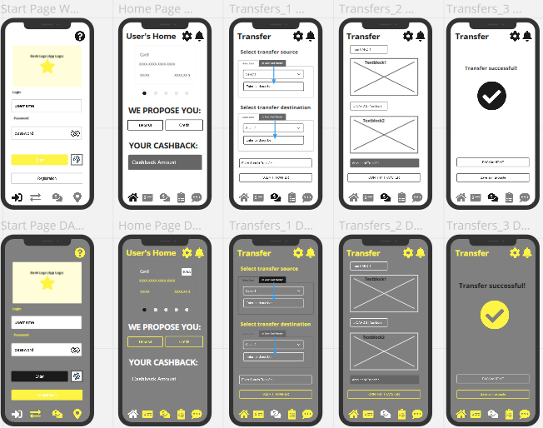

[**https://docs.google.com/document/d/1_e6JiuH8hr11yhek_ewIOFrA9l0pEQDfPIFeOCemxw4/edit?usp=sharing**](https://docs.google.com/document/d/1_e6JiuH8hr11yhek_ewIOFrA9l0pEQDfPIFeOCemxw4/edit?usp=sharing)